

Al-Hussein Technical University

Project Title: Portfolio Builder.

Built by Nasser Hammodeh.

Supervised by Khaled Owies.

Introduction :

A **portfolio** is a compilation of materials that exemplifies your beliefs, skills, qualifications, education, training and experiences. It provides insight into your personality and work ethic.

Why should I have a portfolio?

The process of putting together a portfolio itself will help you become a **more effective interviewee**.

What should be included in my portfolio?

1 - Resume: (add Resume Writing link).  
2 - Skill Areas : (Interpersonal skills and Technical skills).  
3 - About you and your vision.

How to select the best work samples?

Ask yourself which samples show the most skills and competencies?**PORTFOLIO BUILDER** is the best sample of portfolio provider.

The project requirements :

The portfolio builder system is consisting of two layers :

Admin layer and user layer.

Requirements for Admin:

1. Admin must log in using his specified email and password.
2. When the admin logs in, he/she will move to home page.
3. The admin can choose from nav bar which contain three main buttons :

* Users information page that contain tables containing all users which create a portfolio on the site in addition to a button to display each user portfolio and a button to display each user projects.
* Universities information page that contain two tables that present university and major information with button to delete specific university or major in additional to two small forms to add new university and major.
* Skills page that contain two tables that present interpersonal and technical information with button to delete specific skill in additional to two small forms to add new interpersonal and technical skill.

Requirements for user:

1. The home page of the site will appear which contains a definition of portfolio, Answers of why I should have a portfolio, what should be included in portfolio and how to select a portfolio sample which all mentioned in the nav bar.
2. The user must log in to be able to create his own personal portfolio.
3. If the user does not have an account on the web site, then he/she must resist to access the web site services.
4. When user creating a new account for the first time, the user will be moved to the information form page and fill the required information.
5. The information that website required it consists of three section :
6. Personal information :

* First, second and last name
* Date of birth
* Mobile number
* Gender
* Address
* About and vision
* E-mail
* Curriculum Vitae file
* Personal image

1. Social media information

* Facebook URL
* LinkedIn URL
* Twitter URL

1. Educations information

* University name
* Degree of certificates
* Major name

1. Skills information

Which contain

* Interpersonal skills
* Technical skills

1. Project information

* Project name
* Project description
* Project image and project file
* Project file

1. The user will not be transferred to the next page unless all the information requested from him has been filled out, which are his personal information, Education information, his/her interpersonal and technical skills and the previous projects details.
2. When a user has filled out all his information and clicks the create button, an email will be sent to him/her with a link of his/her portfolio.
3. When the website sends an email to a user, the website will take him/her to their own portfolio page.
4. On the Portfolio page, the user can choose between either updating or delete his/her portfolio.
5. If the user chooses the option to update his/her portfolio, website will be transferred to the updating form page, and the user will be able to update the information he wants to edit.
6. Before pressing the update button, the user must make sure that all fields are full of information, otherwise it will not move him to the next page with warning on empty fields.
7. When he/she click update button, he/she will be moved to the Portfolio page, and all the changes made by the user will be displayed.
8. But if the user chooses to press the delete button, the website will delete all his/her portfolio information but keep the username and the password that referring to his/her account and transferred to the home page of the site where there is general information that mentioned about the site.
9. When the user finishes using the site, he logs out of his account.
10. When the user logs out from the site, he is moved to home page.

Use case :

Repositories source code :

1. User repository

* Add user

* Update user

* Delete user

* Get user

* Get user skill

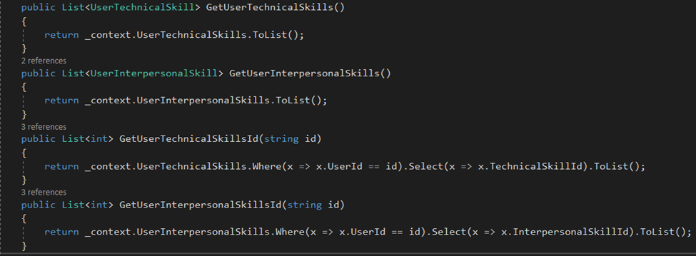

* Get user universities

* Get user projects

1. User university repository :

1. User skill repository

* Add skill

* Get skills

* Delete skill

1. Degree repository

Website images :

Home page

Home page navbar for public user

Home page navbar for logged in user

Log in page

Register page

Create form page

Update form page

Portfolio about section

Portfolio education section

Portfolio skills section

Portfolio projects section

